**Assisted Practice: 3.14 Set the Storage Class of an Object**

This section will guide you to:

* Set the storage class of an object

This lab has three subsections, namely:

3.14.1 Selecting the bucket

3.14.2 Setting the storage class of an object

3.14.3 Pushing the files to GitHub repositories

**Step 3.14.1:** Selecting the bucket

* Select the bucket and open the list of items

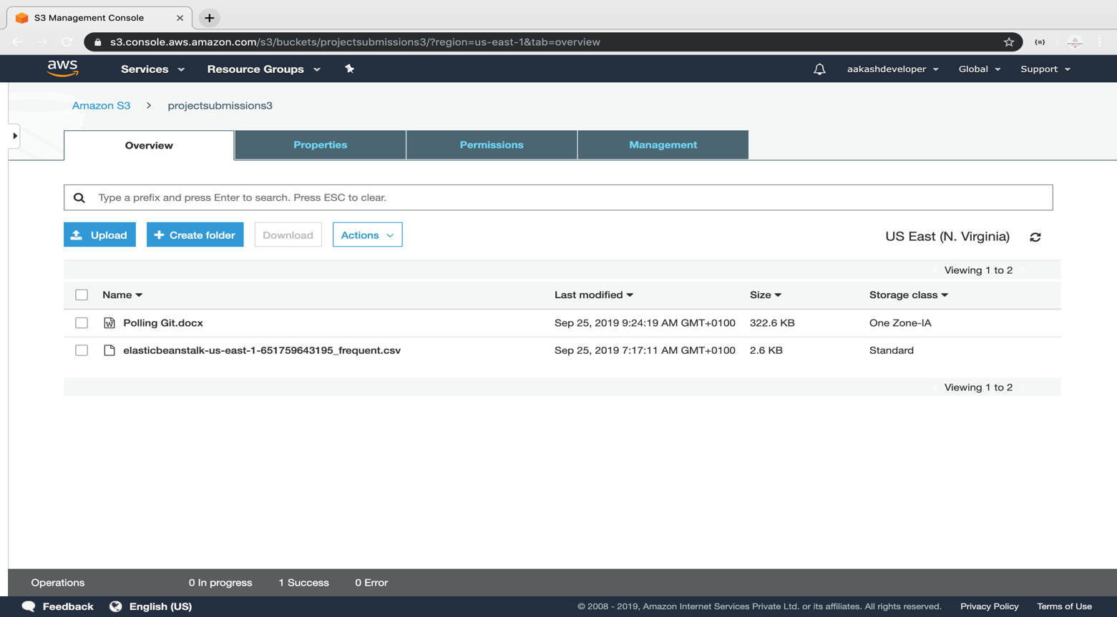

**Step 3.14.2:** Setting the storage class of an object

* Click on *Upload* and select the file and click *Next*

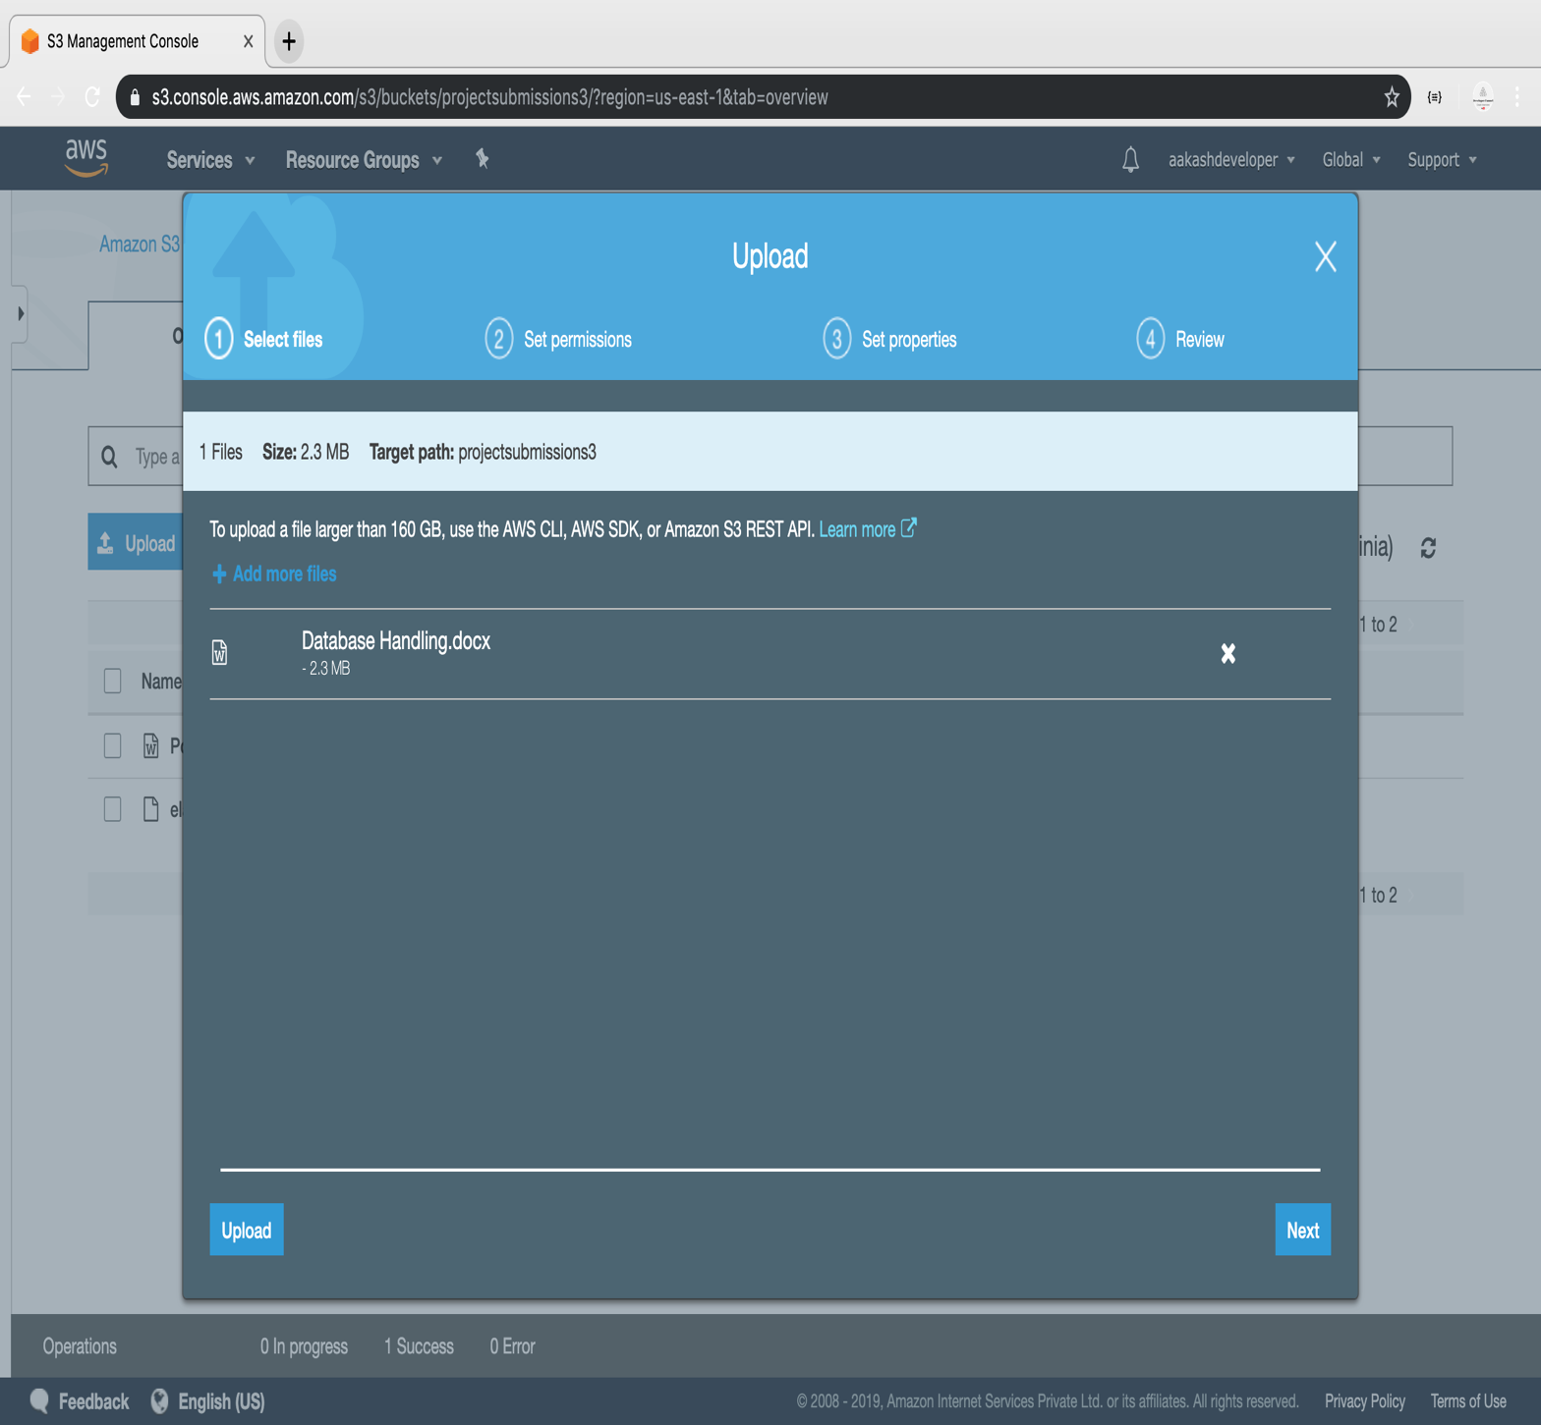

* Select the class and click *Next*

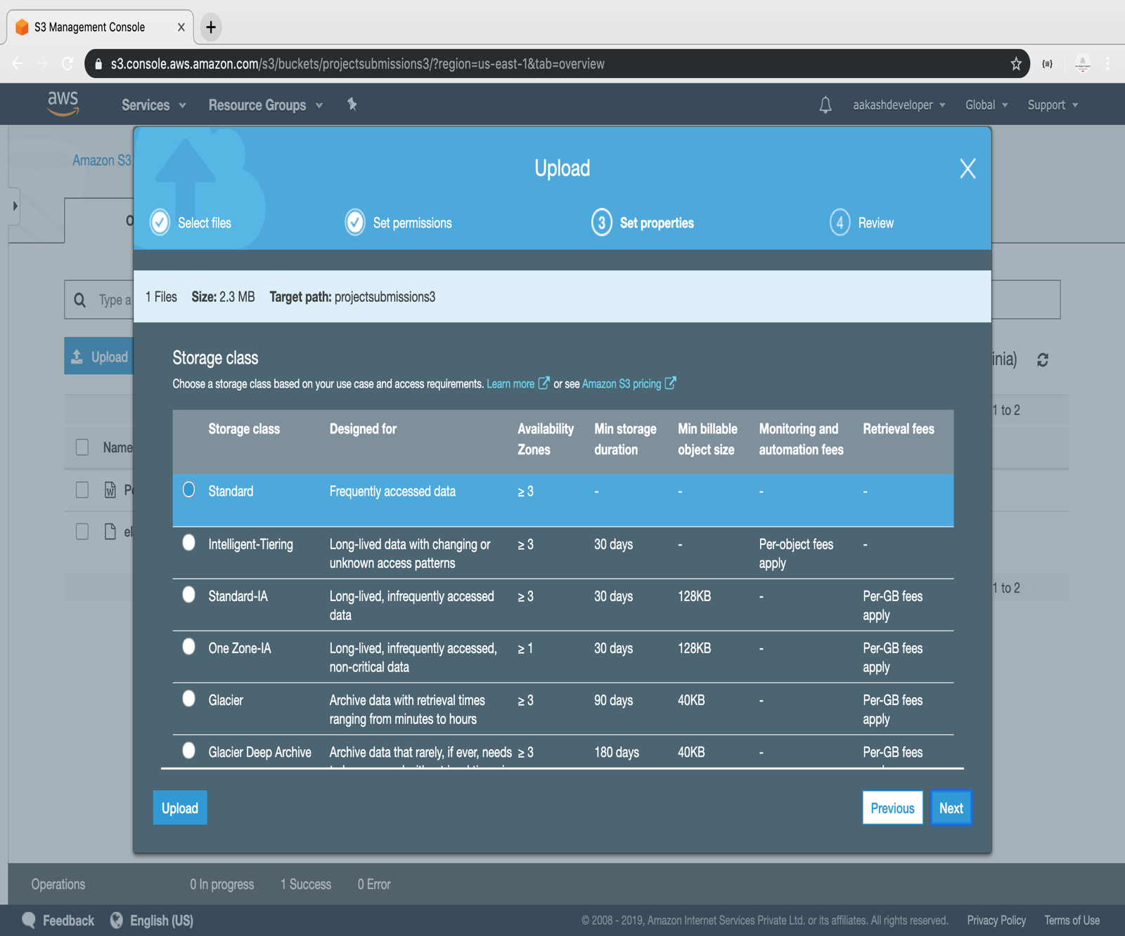

* The class will get assigned to the uploaded object

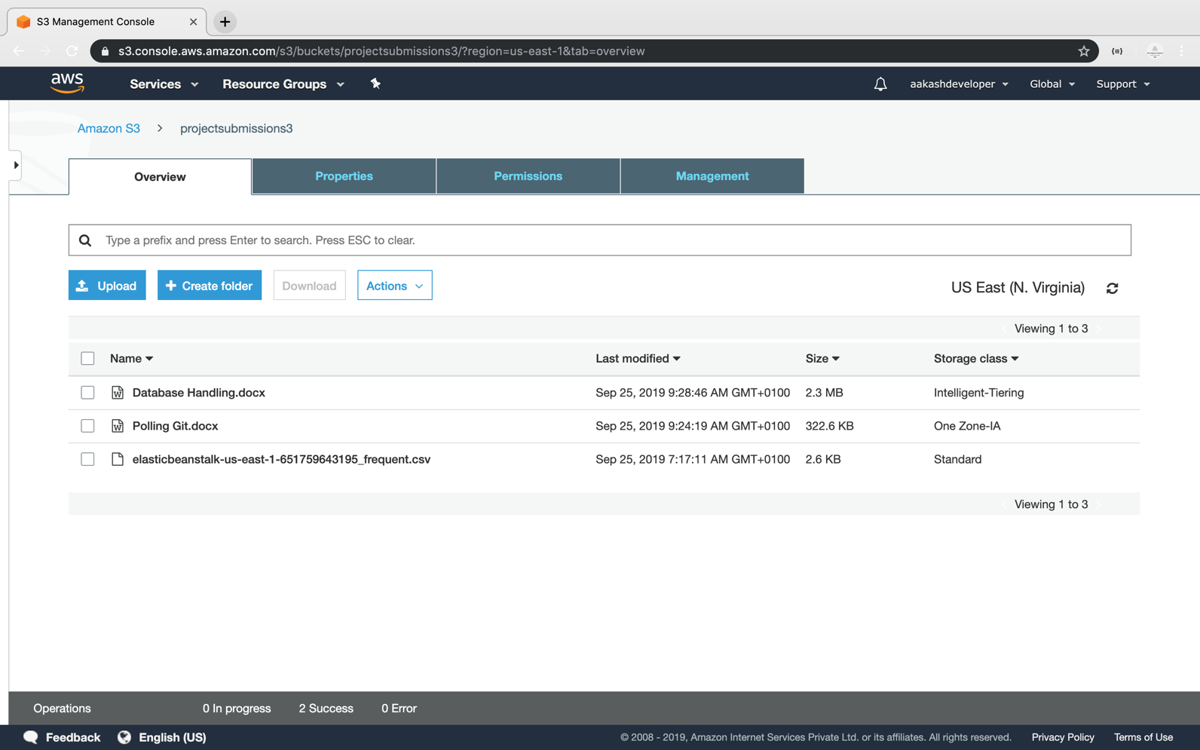

**Step 3.14.3:** Pushing the code to your GitHub repositories

* Open your command prompt and navigate to the folder where you have created your files.

**cd <folder path>**

* Initialize your repository using the following command:

**git init**

* Add all the files to your git repository using the following command:

**git add .**

* Commit the changes using the following command:

**git commit . -m “Changes have been committed.”**

* Push the files to the folder you initially created using the following command:

**git push -u origin master**